**Concept ideas:**

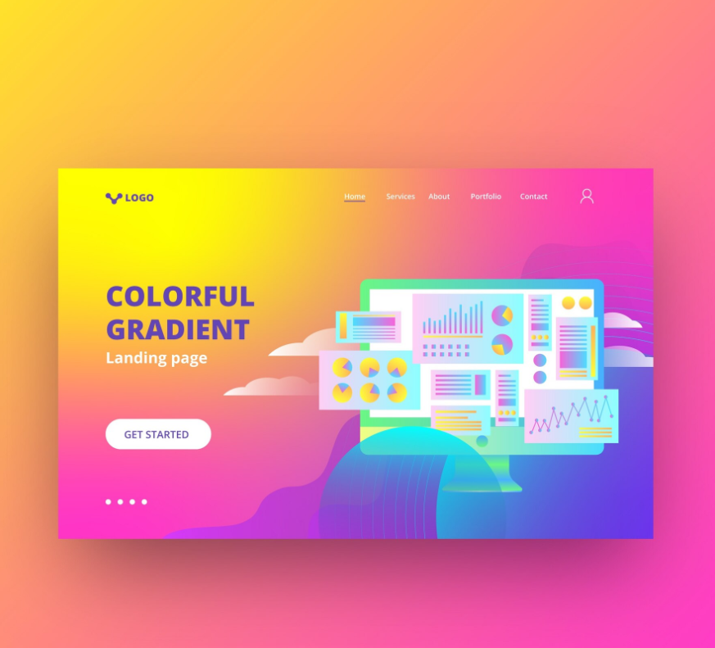

This is a possible idea of how the home page would look like. A warm colour palette gradient

**(Concept 1)**

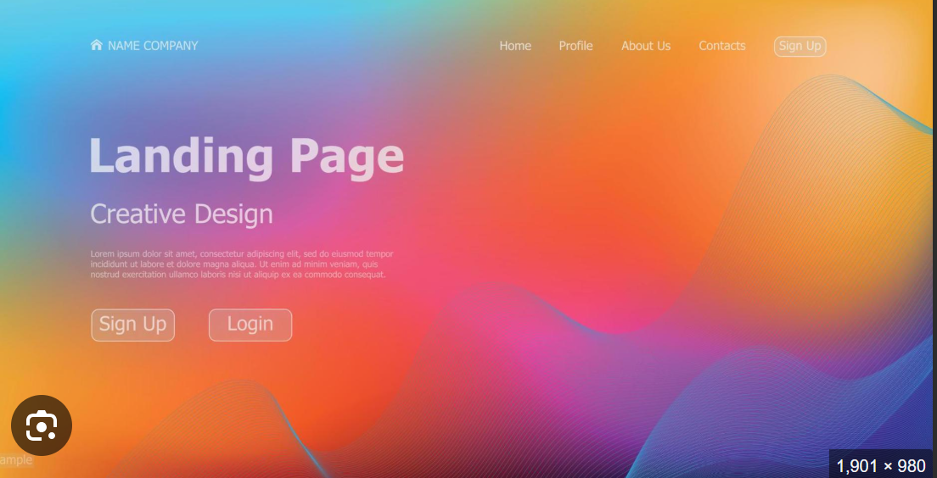

Another feasible idea but a similar concept would be to incorporate more colours using cool colours thus not restricting to only warm colours. To help with a more fresh and more appealing design, I feel its better to use this concept mixed (cool + warm colour gradient). However, colour selection have to be used more carefully. (**concept 2)**

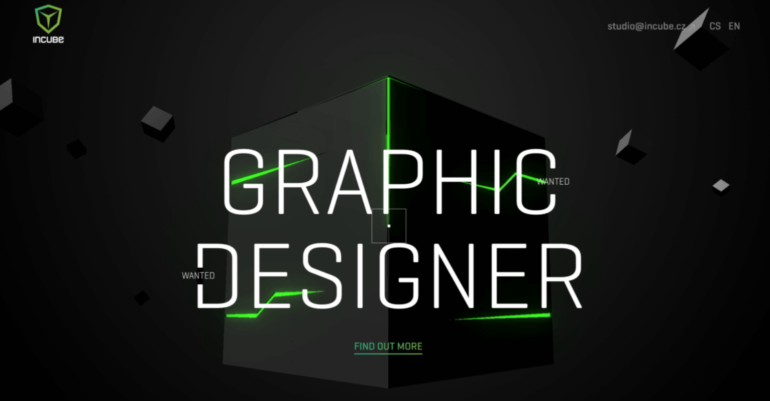

Another style would be a dark background (not black for sure because it is very common) and elements and fonts would be designed in a futuristic neon style. Neon glow and vibrant colours would be injected to content accordingly. **(concept 3)**

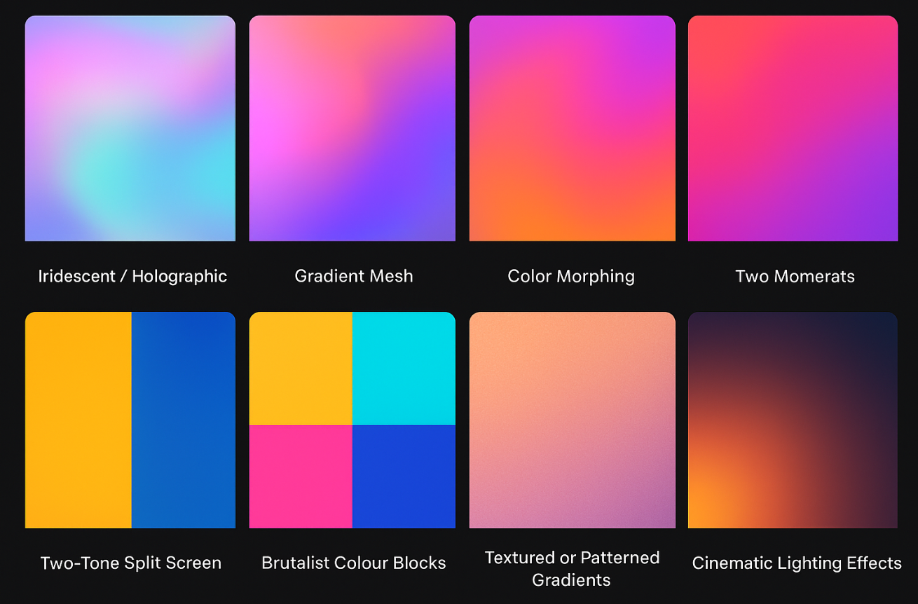



Researched from chatgpt, they are different style of gradients and they can be perceived accordingly in different meanings.

It also recommends not to use a vibrant but more soft gradient which I completely agree with it as because we are supposed to draw more attention to the works than the theme itself.

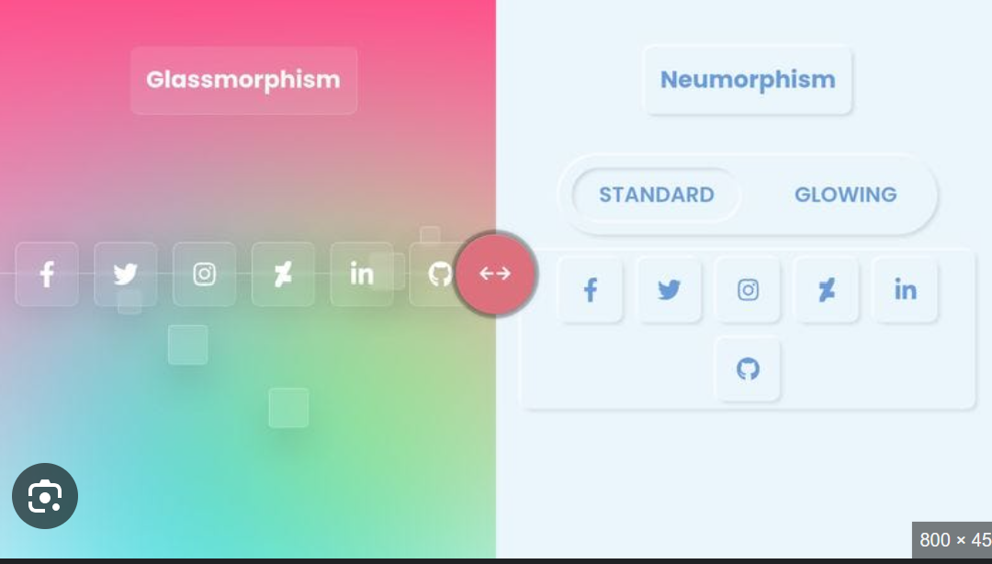

Another Great concept would be glassmorphism and neumorphism. Instead of a fully gradient theme. The other content could benefit from frosted gradient glassmorphism alongside with the gradient background. Neumorphism helps with a more professional and more organised look. **(concept 4)**

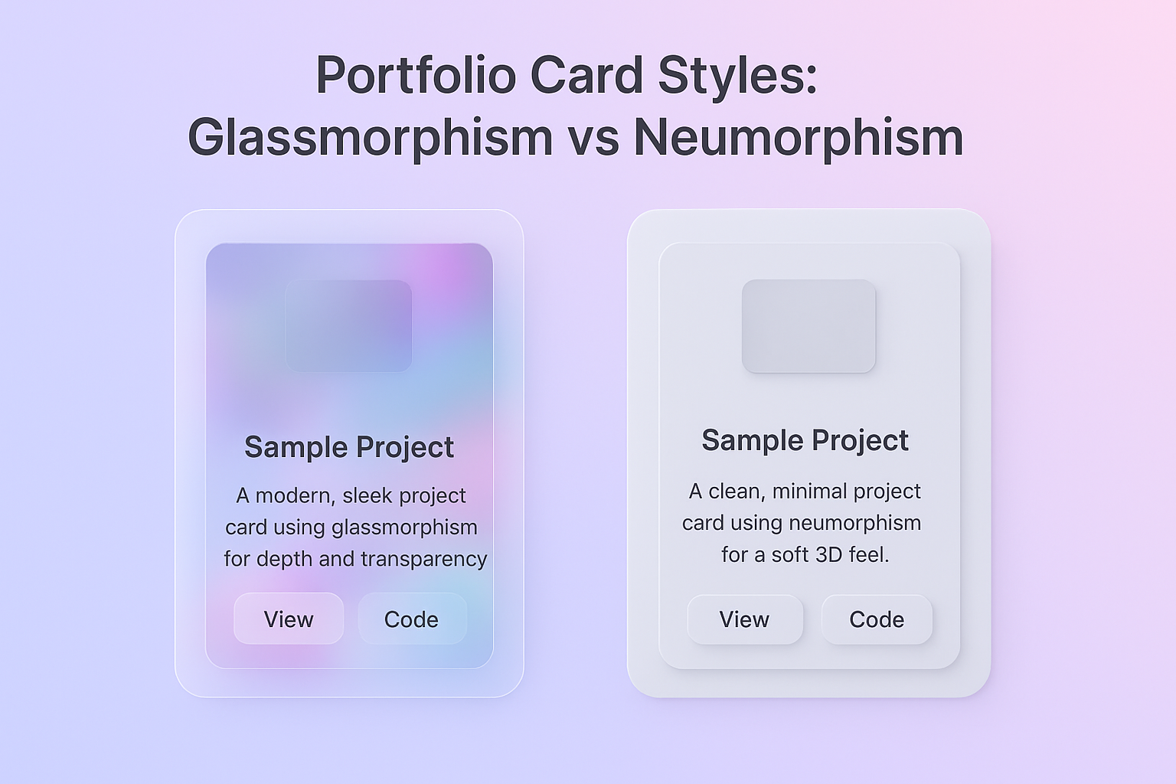

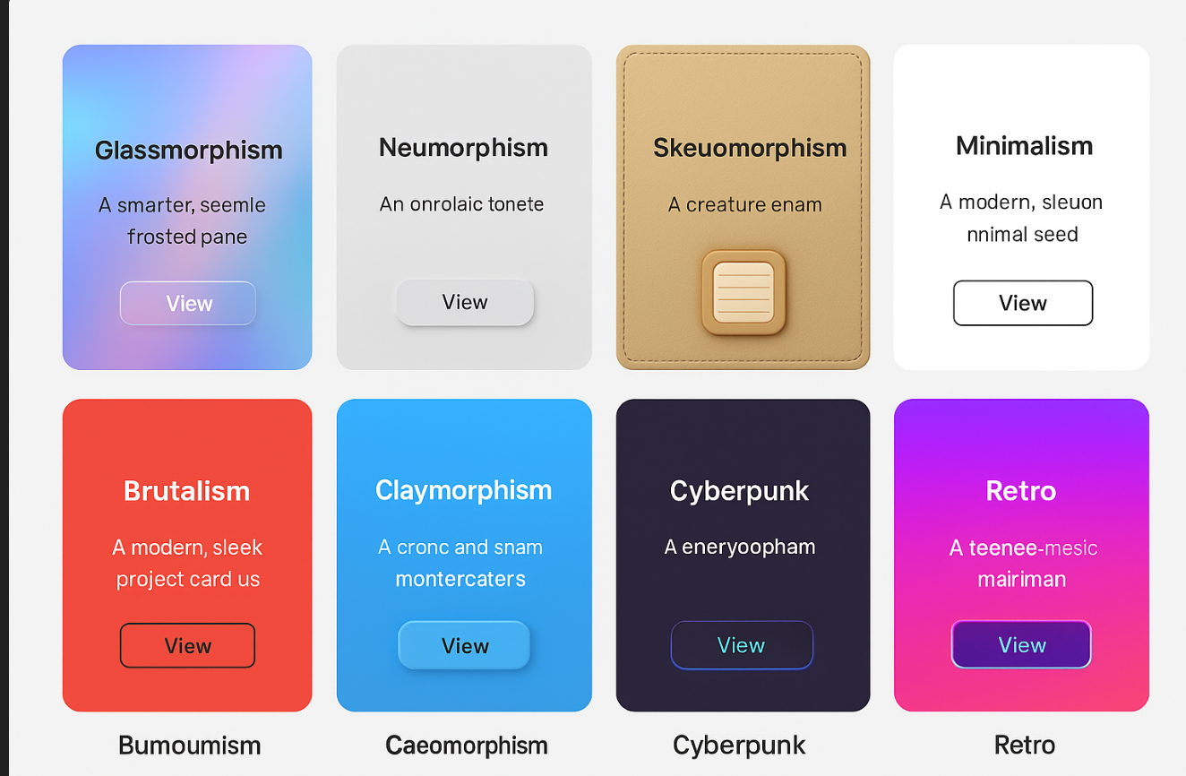

Based on chatgpt, more concept styling, perharps mine is based on claymorphism because I intend to make it colourful so maybe my website is based on a blend of glassmorphism, neumorphism and claymorphism gradient

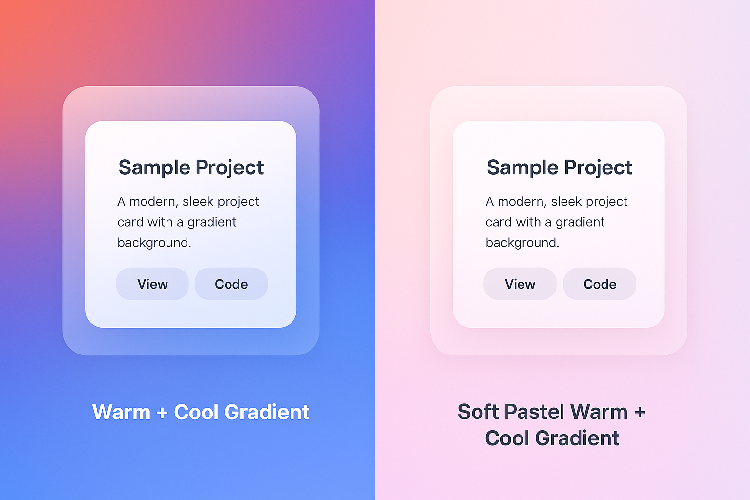

A pastel gradient might be much better for the portfolio section and a standard gradient for the home page. Since each page should convey a different meaning

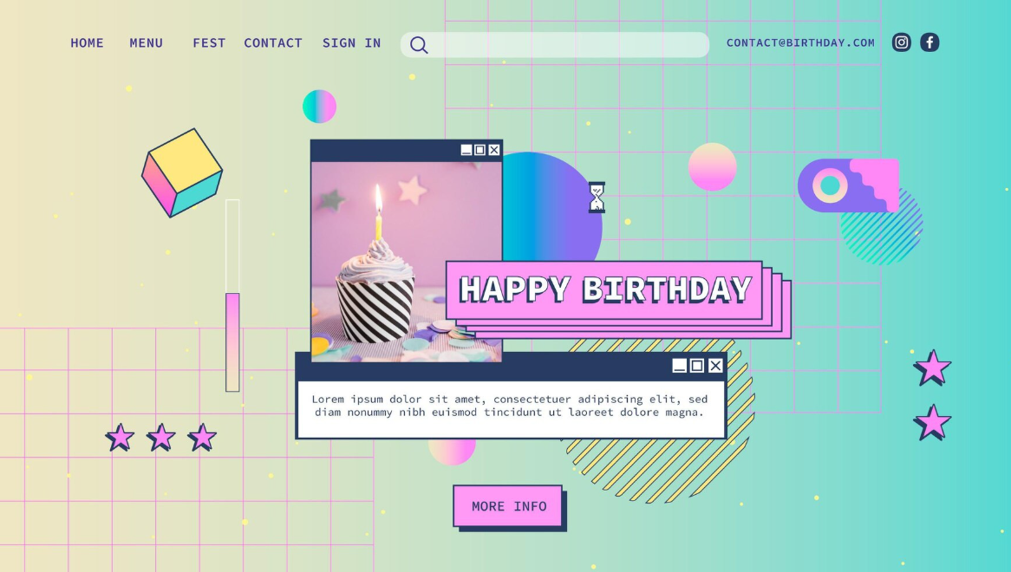

Modern vaporwave, similarly to this if I chose this, will utilise shapes for decoration, light gradient background, vibrant gradient noteboxes while utilising a futuristic font.

**(concept 5)** explanation from chatGPT below.

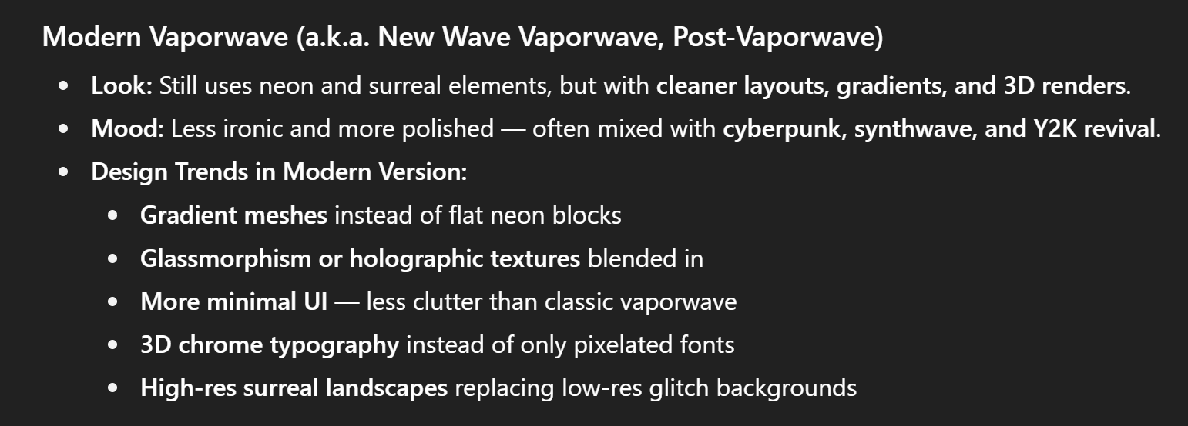

**Ideas considered from senior PD:**

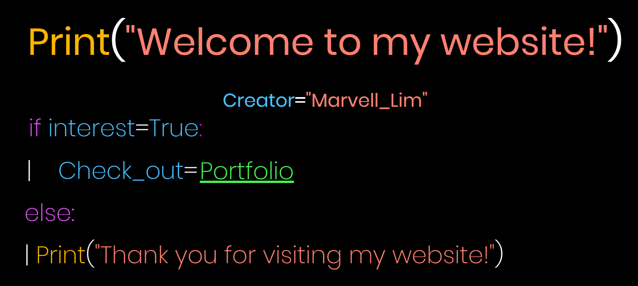



It has a interesting way to direct users to visit his portfolio using the python style syntax. One of the problems that his font size is not consistent and a improvement he could done is to make this stand out by creating a background.

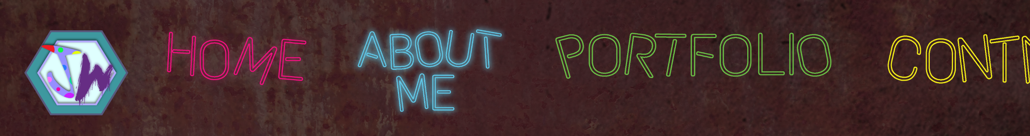

The font for navbar gives a neon glow but however the navbar theme does not complement that neon glow of the font. The font style may not be ideal for target audience (which is workplace employers in this context)

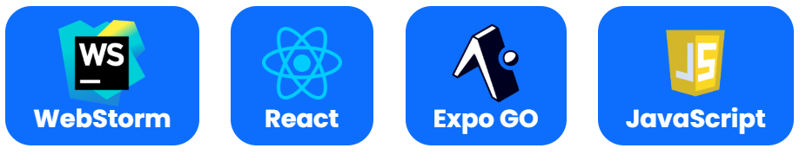

This is a good way to show "list of apps used for a project", I will adjust the curve box colour to suit my theme.

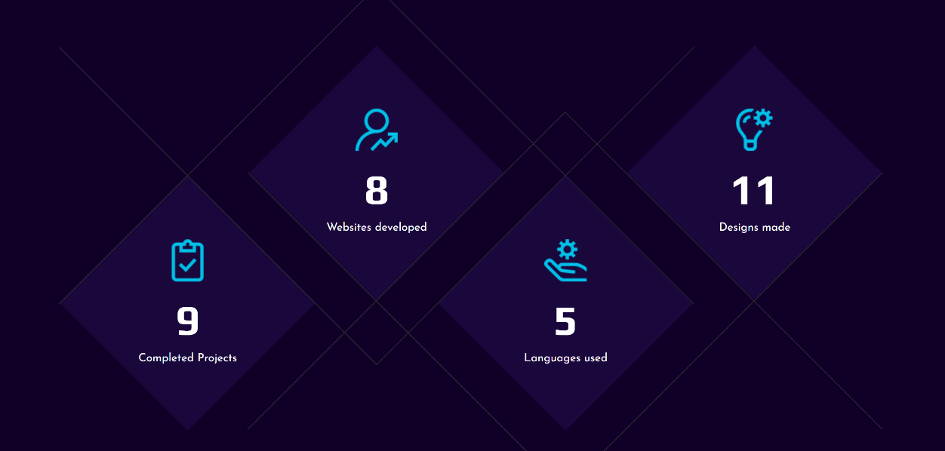

It is a modern way of designing and a way to make the homepage more lively. To adapt to my theme, likely I can incorporate this into my homepage by adjusting adjusting the corner into curvesand changing the straight line into a curves line (wave-style)

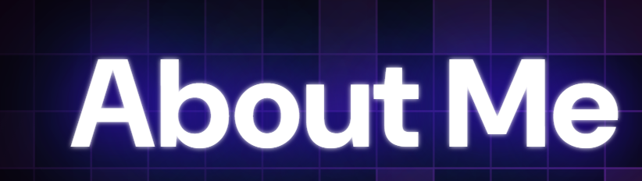

Giving a h1 font a shadow glow could be a good way to make it stand out

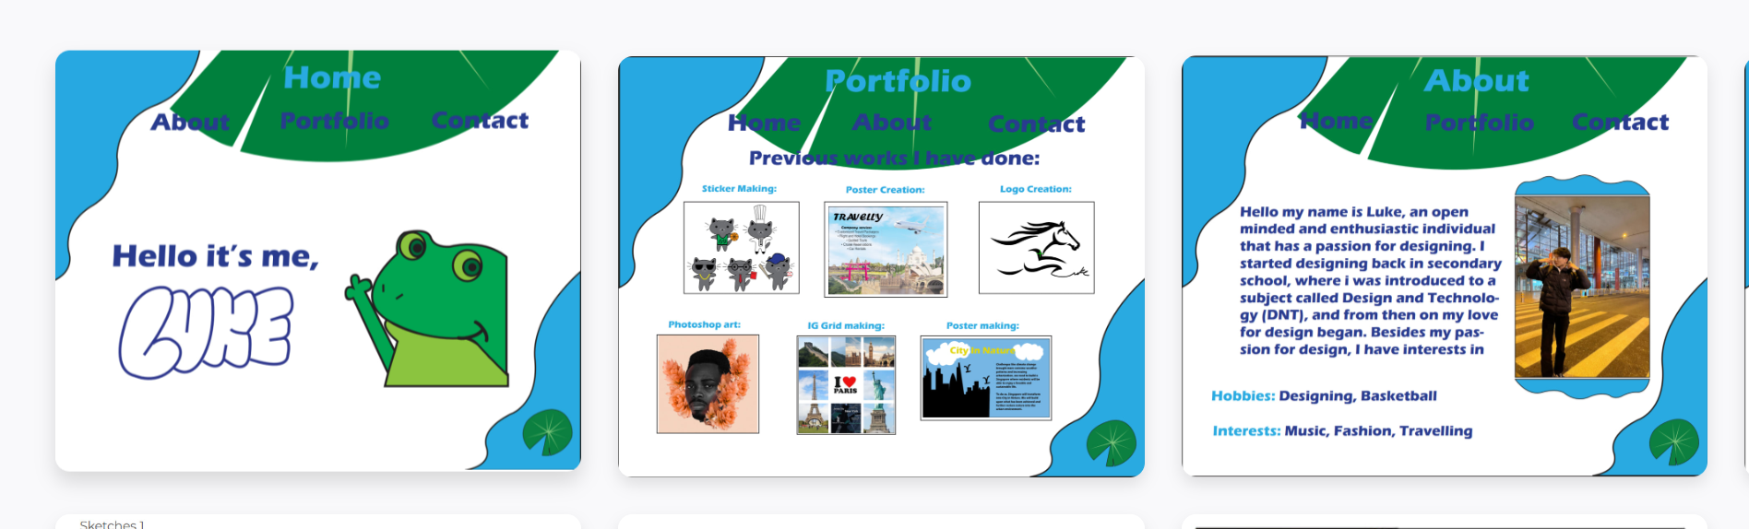



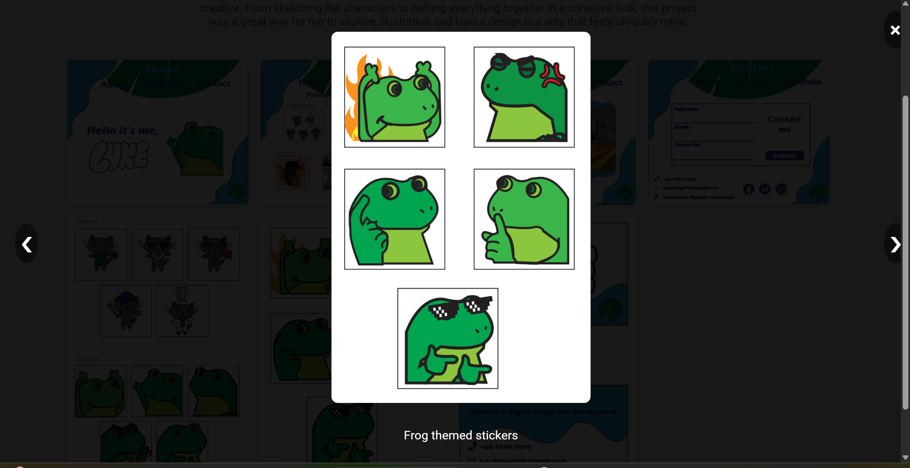

A gallery would help display each individual works in a organised way but I think to preserve the image quality we should not style the image on the main works page. It is really nice to click the image and view it in details allowing users to "see more of your work"



This senior website have this feature for my about page. I feel being being a D3D student, we learn both designing and development skills thus having this can indicate to our employers where we lean towards too.





This website uses a navbar that is semi transparent so it does not conflict with the background colour

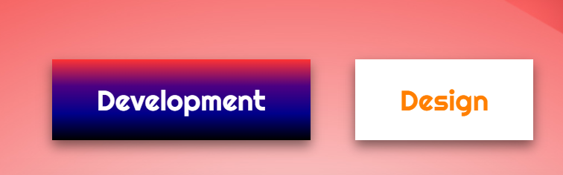

This website a filter which displays works belonging to that category but I think it would be better if there is a filter which allow users to click all works.



Adding a glow to notebox helps bring more life to the website the notebox feels more appealing to look at, Feedback received: (can consider other) design trends

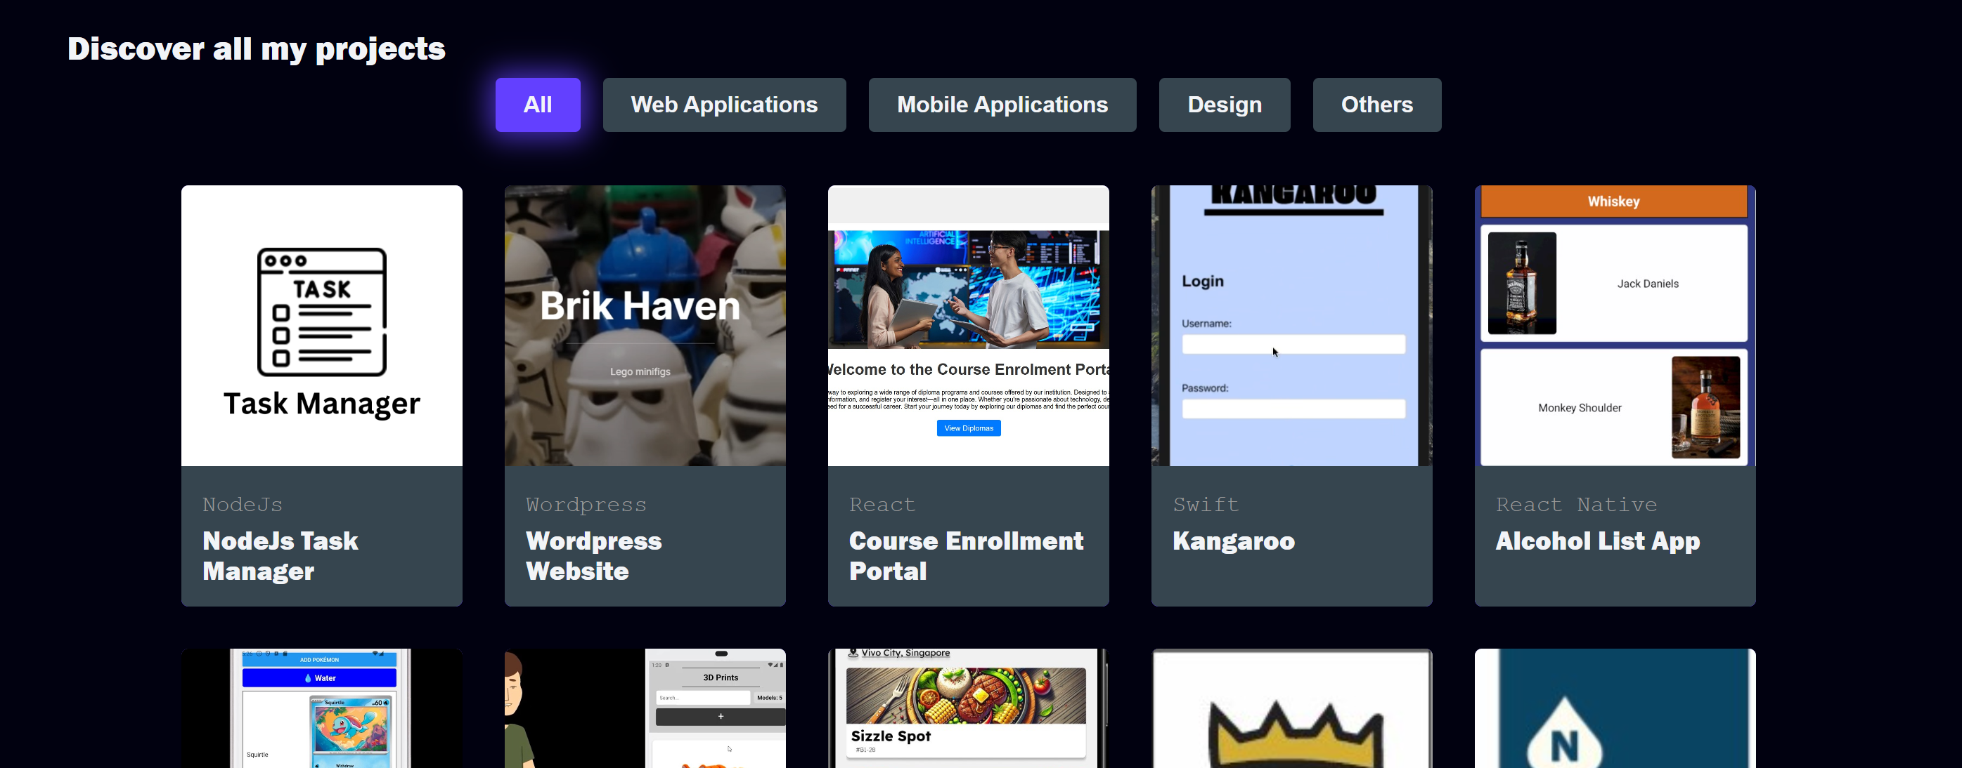

A way of filtering works into its more specific categories but to make the website neater (more minimal) All, design and development filter is good enough.

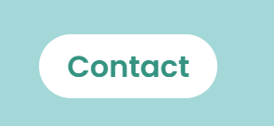

If I do not have a navbar, maybe can do a frosted curve box around the link (sticky button) However when user is active on that page, then probably could have a colour curve box similar to the image above.

However, I prefer continuous feel thus navbar better.

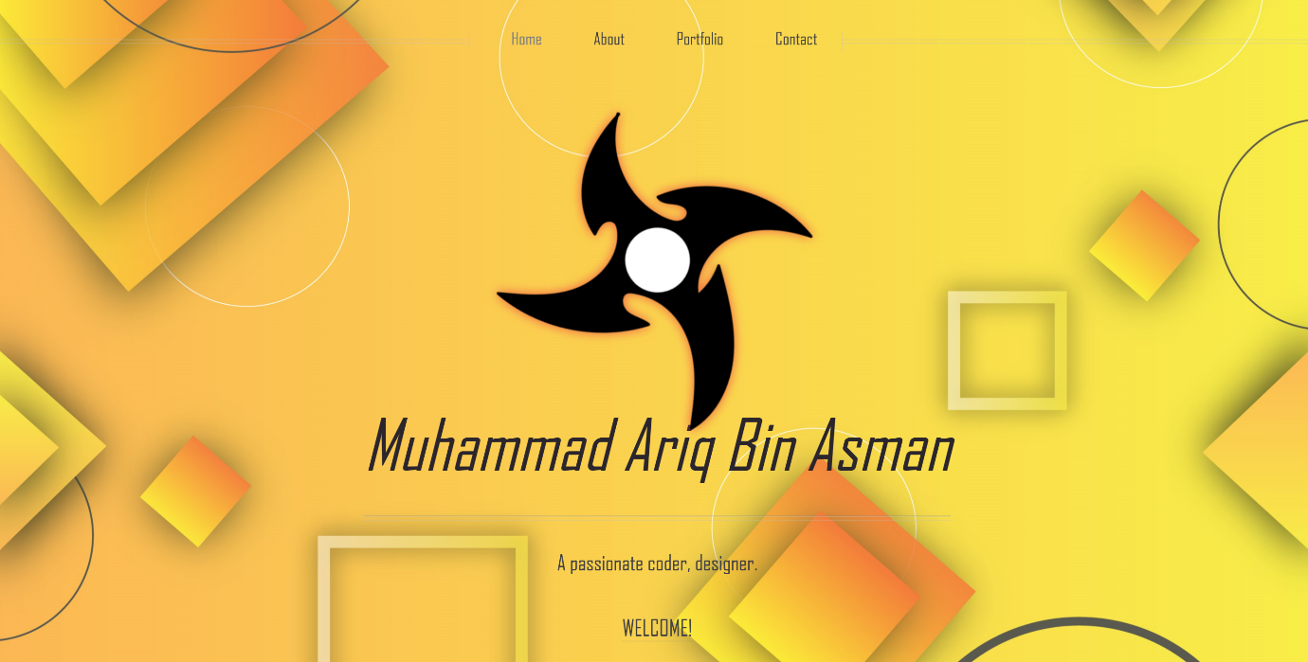



A unique homepage filled with many variety of elements

**Documentation:**



Gradient navbar



Transparent navbar

